**VISVESVARAYA TECHNOLOGICAL UNIVERSITY**

**“JnanaSangama”, Belgaum -590014, Karnataka.**



**MOBILE APPLICATION DEVELOPMENT REPORT**

**on**

**DEMENTIA VIRTUAL MEMORY APP**

***Submitted by***

**DIKSHA NADIGA (1BM22CS089)**

**BHAVYA HANWITHA(1BM22CS095)**

**HADIA FATHIMA (1BM22CS106)**

**HEMA P (1BM22CS111)**

***Under the Guidance of***

|  |  |
| --- | --- |
| **Dr Rajeshwari BS**  **Associate Professor, BMSCE** |  |

***in partial fulfillment for the award of the degree of***

**BACHELOR OF ENGINEERING**

***in***

**COMPUTER SCIENCE AND ENGINEERING**



**B.M.S. COLLEGE OF ENGINEERING**

**(Autonomous Institution under VTU)**

**BENGALURU-560019**

**April-2024 to July-2024**

**B. M. S. College of Engineering,**

**Bull Temple Road, Bangalore 560019**

(Affiliated To Visvesvaraya Technological University, Belgaum)

**Department of Computer Science and Engineering**



**CERTIFICATE**

This is to certify that the project work entitled “**DEMENTIA VIRTUAL MEMORY APP**” carried out by **DIKSHA NADIGA(1BM22CS089), BHAVYA HANWITHA (1BM22CS095), HADIA FATHIMA (1BM22CS106) AND HEMA P (1BM22CS111)** who are bonafide students of **B. M. S. College of Engineering.** It is in partial fulfillment for the award of **Bachelor of Engineering in Computer Science and Engineering** of the Visveswaraiah Technological University, Belgaum during the year 2023-2024. The project report has been approved as it satisfies the academic requirements in respect of **Mobile Application Development (23CS4AEMAD)** work prescribed for the said degree.

Signature of the Guide                 Signature of the HOD

Dr Rajeshwari BS Dr. Jyothi S. Nayak

Associate Professor, Dept. of CSE Prof.& Head, Dept. of CSE

BMSCE, Bengaluru BMSCE, Bengaluru

External Viva

Name of the Examiner                                                                                       Signature with date

1._____________________________ ________________________

2. _____________________________ _________________________

**B.M.S. COLLEGE OF ENGINEERING**

**DEPARTMENT OF COMPUTER SCIENCE AND ENGINEERING**



***DECLARATION***

We, DIKSHA NADIGA (1BM22CS089), BHAVYA HANWITHA (1BM22CS095), HADIA FATHIMA (1BM22CS106), HEMA P (1BM22CS111), students of 4th Semester, B.E, Department of Computer Science and Engineering, B. M. S. College of Engineering, Bangalore, hereby declare that, this Mobile Application Development entitled "Dementia Virtual Memory App" has been carried out by us under the guidance of Dr Rajeshwari BS, Associate Professor, Department of CSE, B. M. S. College of Engineering, Bangalore during the academic semester April-2024 to July-2024

We also declare that to the best of our knowledge and belief, the development reported here is not from part of any other report by any other students.

Signature

DIKSHA NADIGA (1BM22CS089)

BHAVYA HANWITHA (1BM22CS095)

HADIA FATHIMA (1BM22CS106)

HEMA P (1BM22CS111)

**Table of Contents**

|  |  |  |
| --- | --- | --- |
| **Sl. No.** | **Topic** | **Page No.** |
| 1. | Abstract |  |
| 2. | Introduction |  |
| 3. | Hardware and Software Requirements |  |
| 4. | Design Layouts:Screenshots of Mobile App |  |
| 5. | Database Table screen shots |  |
| 6. | Conclusion and Future Work |  |
| 7. | References |  |

**Abstract**

CogniAid is an innovative virtual memory app specifically designed to support individuals with dementia and their caregivers. The app offers a range of features aimed at enhancing daily life and promoting well-being. Key features include a Mood Tracker that helps monitor emotional well-being over time, providing valuable insights into the user’s mental health. Personalized profiles allow users to tailor the app to their individual needs, ensuring a customized and user-friendly experience.

CogniAid also includes a comprehensive To-Do list to manage daily tasks and appointments, helping users stay organized and on track. Interactive mind games are incorporated to stimulate cognitive function and keep the mind active. Additionally, the app offers informative article pages that provide valuable insights, tips, and strategies for managing dementia, making it a useful resource for both users and caregivers.

This holistic approach aims to enhance daily life, foster independence, and improve the overall quality of life for individuals with dementia. Looking ahead, CogniAid is committed to continuous improvement and future enhancements. Planned updates include integrating AI-powered insights to provide personalized recommendations, expanding caregiver tools for better coordination and support, adding voice and gesture controls for improved accessibility, and enabling compatibility with wearable devices to monitor physical health and activity levels. Community support features, such as in-app support groups and forums, will also be introduced to connect users and caregivers for shared experiences and advice.

CogniAid is dedicated to empowering individuals with dementia through innovative technology and compassionate care, providing a comprehensive support system that addresses both practical and emotional needs.

**Chapter 1**

**Introduction**

**Welcome to CogniAid: Your Virtual Memory Companion**

Living with dementia can be challenging, both for individuals and their loved ones. We understand the importance of maintaining independence and enhancing quality of life. That’s why we’ve created a user-friendly app designed to support those with dementia in their daily lives.

**Key Features:**

**1. To-Do List:** Stay organized and never miss a task. Our intuitive to-do list helps you manage daily activities, appointments, and important reminders. Each task can be customized with specific details, times, and alerts to ensure you stay on track.

**2. Mood Tracker:** Understanding and monitoring your mood is crucial for overall well-being. Our mood tracker allows you to log your emotions daily, providing valuable insights into your mental health patterns. This feature can help you and your caregivers identify triggers and trends, promoting better emotional management.

**3. Personalized Profiles:** Create a profile that is uniquely yours. Personalize your CogniAid experience by setting up a profile that includes your information and critical details , which will help you as well as the caregiver.

### 4. Interactive Mind Games: Engage your brain with our collection of interactive mind games. Designed to stimulate cognitive function, these games provide enjoyable ways to keep your mind active. Regular mental exercise can help maintain cognitive abilities and improve overall brain health.

### 5. Article Pages: Stay informed with our curated article pages. Access valuable insights, tips, and strategies for managing dementia. Our articles are written by experts and cover a wide range of topics, offering practical advice and the latest research to help you navigate daily challenges.

**Chapter 2**

**Hardware and Software Requirements**

**2.1 Hardware Requirements**

**For Development:**

**PC or Mac**: A computer running Windows.

**Processor**: Intel Core i3 or equivalent minimum, Intel Core i5 or higher recommended.

**RAM**: 8 GB minimum, 16 GB recommended.

**Storage**: At least 10 GB of free disk space.

**Display**: A monitor with a resolution of at least 1280 x 800.

**For Mobile Devices:**

* **Android Devices**: Running Android 5.0 (Lollipop) or higher.

**Storage**: Sufficient free space to install and run the app smoothly.

**2.2 Software Requirements**

**For Development:**

**Operating System**:

* Windows 7 SP1 or later (64-bit)

**Flutter SDK**: Install the latest stable version of the Flutter SDK.

**Android Studio**: Required for Android development. Includes Android SDK, NDK, and other necessary tools.

**Visual Studio Code**: Recommended code editor, with Flutter and Dart plugins installed.

**Git**: Version control system for managing code.

**Android Emulator**: Included with Android Studio. Ensure hardware acceleration is enabled (Intel HAXM on Windows/Mac or KVM on Linux) for better performance.

**For Mobile Devices:**

**Operating System**:

* Android: Version 5.0 (Lollipop) or later.

**Additional Requirements:**

* **Internet Connection**: Required for downloading dependencies and SDKs, and for app features that rely on online data.
* **APIs and Services**: Integration with any external APIs or services, such as mood tracking or reminder services, may require additional setup and access permissions.

**Chapter 3**

**Design Layouts: Screenshots of Mobile App**

**3.1: Introduction pages**

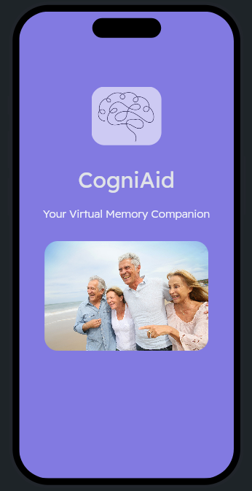 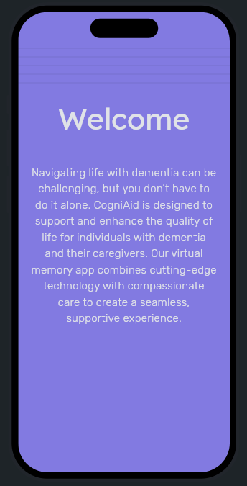 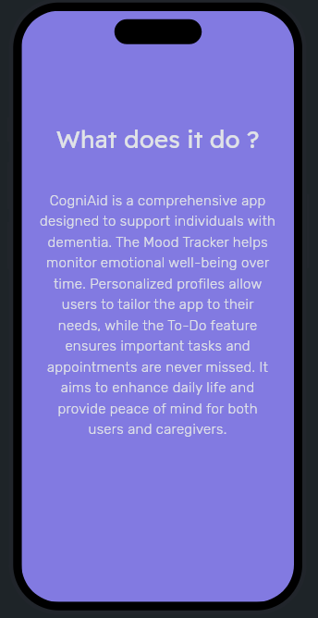

**Fig.1 Introduction page 1 Fig.2 Introduction page 2 Fig.3 Introduction page 3**

**3.2: Login Page**

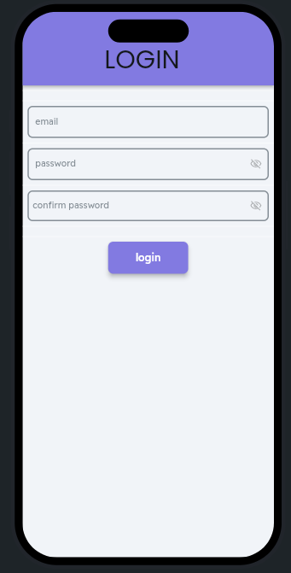

**Fig.4 Login Page**

**3.3: Mood Tracking Pages**

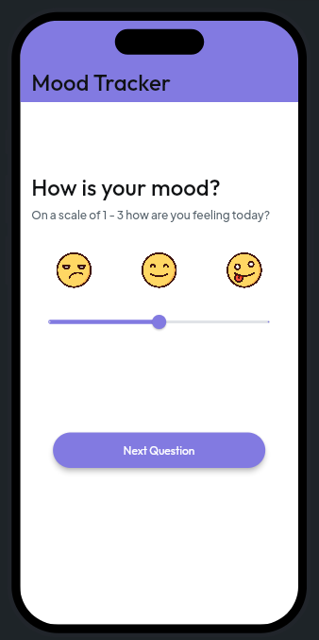 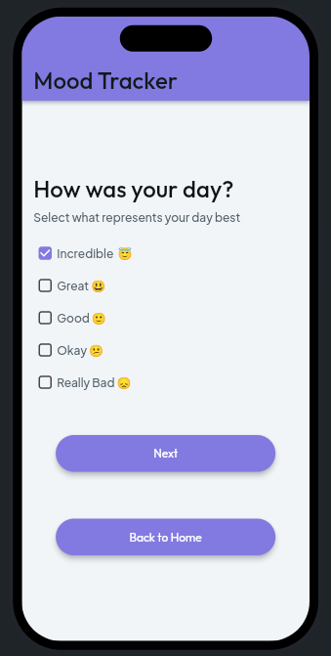

**Fig.5 Mood tracking page 1 Fig.6 Mood tracking page 2**

**3.4: To-Do List**

**Fig.7 To-Do page Fig.8 Add Task page**

**3.5: Profile Page**

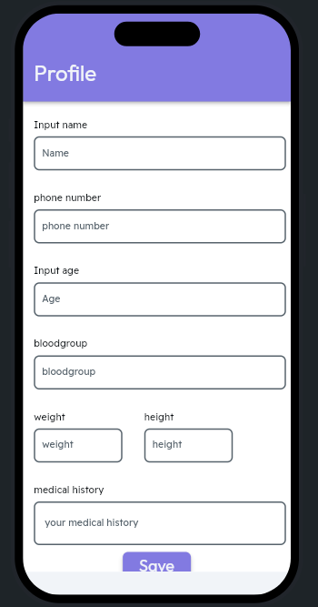 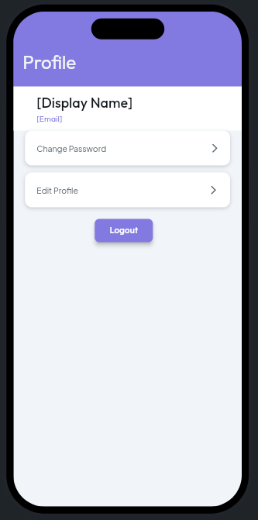

**Fig.9 Profile page 1 Fig.10 Profile page 2**

**3.6: Home Page 3.7: Article Page**

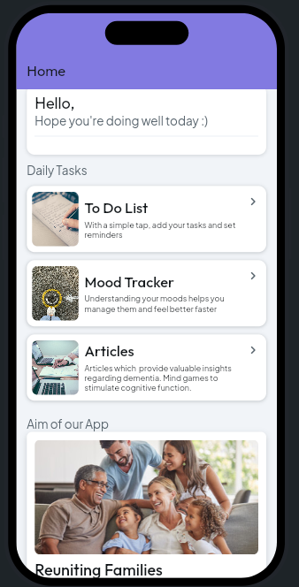 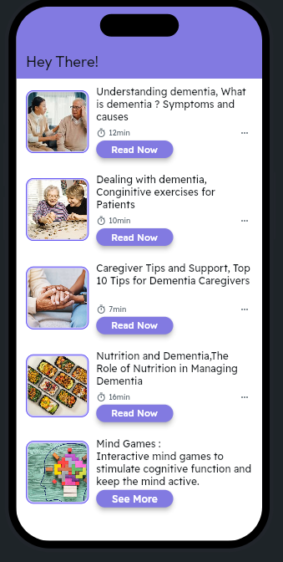

**Fig.11 Home page Fig.12 Articles Page**

**3.8:Articles**

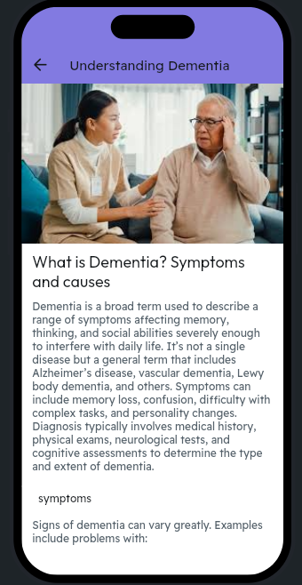 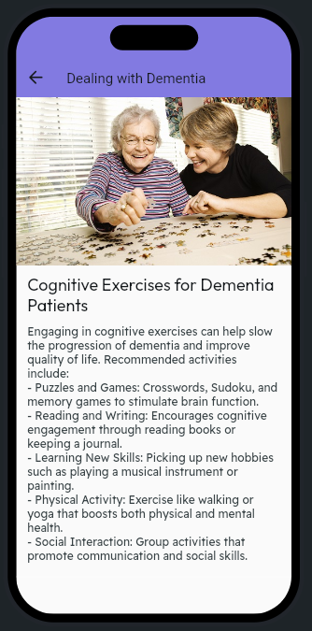

**Fig.13 Article 1 Fig.14 Article 2**

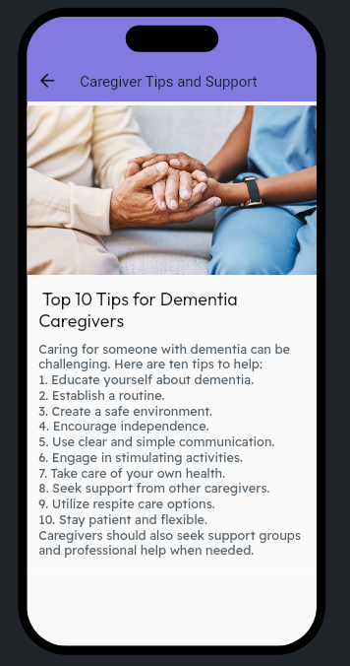 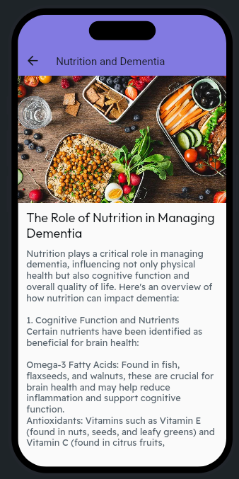

**Fig.15 Article 3 Fig.16 Article 4**

**3.9:Mindgames Page**

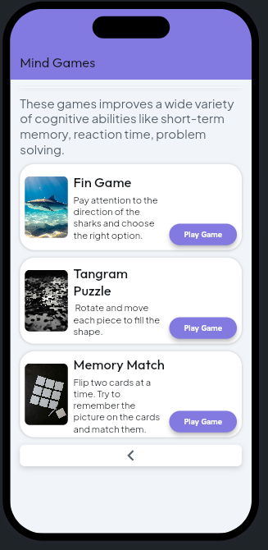

**Fig.17 Mind games**

3.1 Introduction Pages: These pages display our app name with attractive photos and present the need for the app and what it does.

3.2 Login Page: Helps the user to Login into our app and explore all the features

3.3 Mood Tracking Pages: These pages help us to track the mood of the patient on a daily basis which is useful for the doctors for further medications.

3.4 To-Do List: This page allows the patient to add tasks in the task list and maintain a record of whether it is completed or not.

3.5 Profile Page: In this page the patient can input his/her personal details in the page like name, age, phone number, blood group, height, weight and medical history.You can also edit these details or change your existing password.

3.6 Home Page: This page displays all the features of our app in one screen from which u can navigate to the other pages.

3.7 Article Page: This page displays all articles present in the app which helps with the patient’s day to day activities.

3.8 Articles: These pages are all the individual article pages which covers the topics like “Understanding Dementia”, “Dealing with Dementia”, “Nutrition and Dementia” and “Caregiver Tips and Support”.

3.9 Mindgames Page: This page contains various Mind Games which help the patients with their brain capacity.On clicking the “Play Game” button it directs the patients to the site of the game where he/she can play it.

**Chapter 4**

**Database Table Screen shots**

4.1.1. Course Registration Database Table: Description

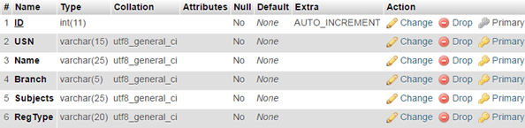

4.1.2 Course Registration Database Table: Data

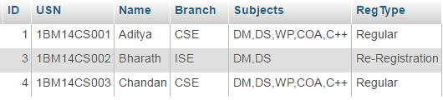

3.2.1. Login Users Database Table: Description

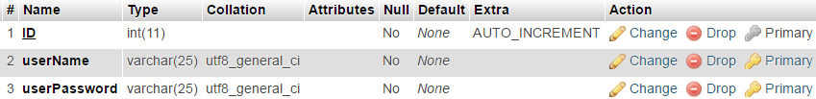

3.2.2 Login Users Database Table: Data



4.2 ER Diagram

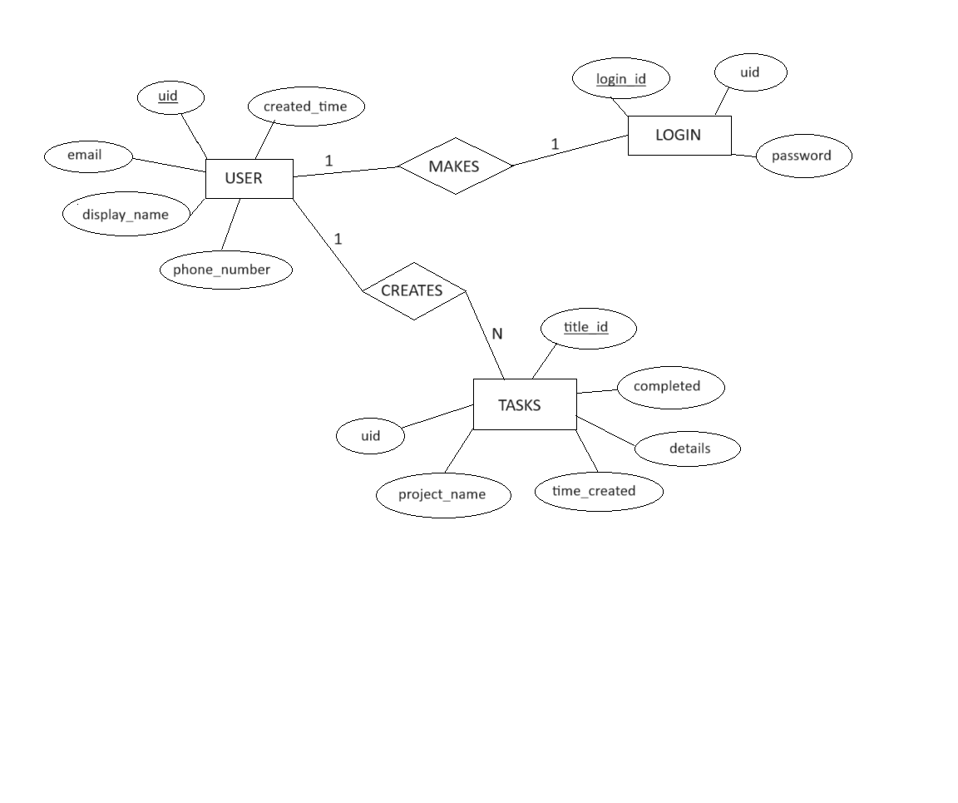

**Fig 4.2: ER diagram of Database**

**Chapter 5**

**Conclusion and Future Work**

**Conclusion**

CogniAid is dedicated to improving the quality of life for individuals with dementia and their caregivers through innovative technology. By combining features such as a Mood Tracker, personalized profiles, and a comprehensive To-Do list, we strive to offer a holistic support system that addresses both daily needs and emotional well-being. We hope that CogniAid provides a sense of independence, connection, and ease to all who use it.

**Future Work**

Looking ahead, we are committed to continuously enhancing CogniAid. Future updates will include:

- AI-Powered Insights:Advanced analytics to provide personalized recommendations and insights based on user data.

- Expanded Caregiver Tools: Enhanced collaboration features for caregivers, including shared calendars and progress tracking.

- Voice and Gesture Controls: Improved accessibility with voice and gesture navigation for users with varying abilities.

- Integration with Wearables:Sync with wearable devices to monitor physical health and activity levels.

- Community Support: In-app support groups and forums to connect users and caregivers for shared experiences and advice.

**References**

1. <https://en.wikipedia.org/wiki/Flutter_(software)>
2. Understanding Dementia: <https://www.alz.org/alzheimers-dementia/what-is-dementia>
3. Dementia Fact Sheet: <https://www.who.int/news-room/fact-sheets/detail/dementia>
4. Inclusive Design Tips: <https://www.inclusivedesigntoolkit.com/whatis/whatis.html>
5. Task Management App Development: <https://flutter.dev/docs/cookbook/design/todo-list>
6. Developing Mood Tracking Features: <https://pub.dev/packages/fl_chart>
7. Task Management App Development: <https://flutter.dev/docs/cookbook/design/todo>